A An Truong Primary School.  Full name: …………………………......  Class: ………………… | THE FRIST TERM TEST FOR GRADE 5  School year: 2025-2026  Time allowed: 60 minutes
Skills | Listening | Reading | Writing | Speaking | Total
Marks
Comments: |  |  |  | Supervisor singnature
LISTENING (3 marks)
TASK 1. Listen and tick. (1 mark)

1.  a  b  b  a  a  b  a  b | 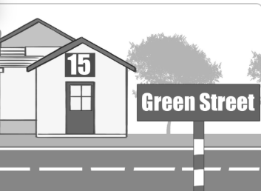 | 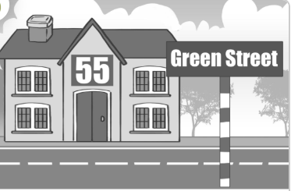
2. | 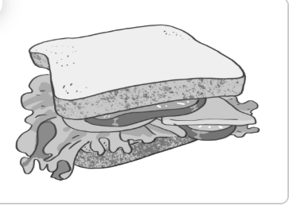 | 
3. | 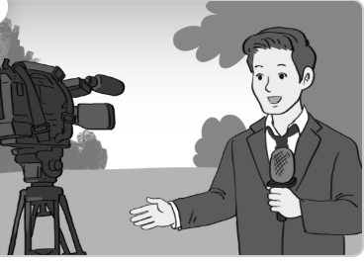 | 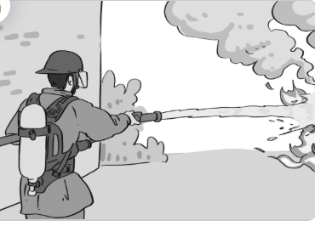
4. |  | 

TASK 2. Listen and circle. (1 mark)
1. A: Where’s the computer room?  B: It’s on the ________.  a. second floor b. third floor | 2. A: What school activity does Lucy like?  B: She likes ________.  a. doing projects b. reading books
3. A: Whose crayon is this?  B: It’s ________.  a. Mai’s b. Linh’s | 4. A: What did Mai’s class do at the campsite yesterday?  B: They ________.  a. listened to music  b. danced around the campsite
TASK 3. Listen and tick True or False. (0.5 mark)

 | True | False
1. Nam would like to be a reporter.
2. He would like to work in an office.

IV. SPEAKING (2.5 MARKS)
Part 1: Answer the questions (1.5 marks)
The examiner asks 6 questions below:
1.What’s your name?
2. How are you?
3. Where do you live?
4. What’s your favourite colour?
5. Do you like swimming?
6. What did you do yesterday?
Part 2: Look and answer the questions (1.0 mark)
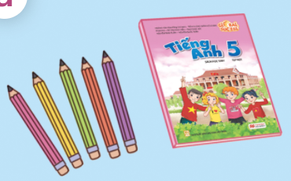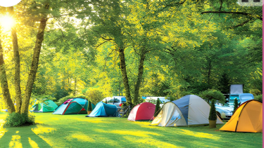
4. Were you at the campsite yesterday?
3.What did they do there?
2. Where are the
pencils?
1. What would you like to be in the future?

A An Truong Primary School.  Full name: …………………………......  Class: …………………………… | THE FRIST TERM TEST FOR GRADE 5  School year: 2025-2026  Time allowed: 30 minutes
READING (2.5 MARKS )
TASK 1. Look and tick ☑ or cross 🗵.(1.25 marks)
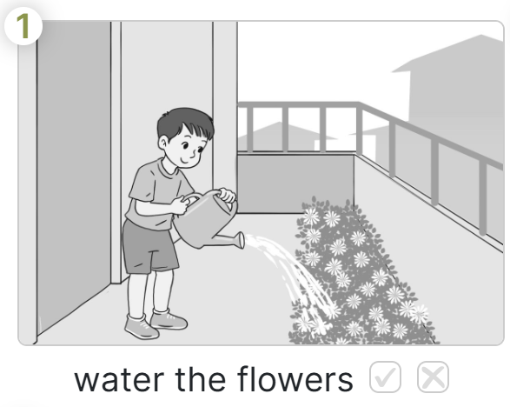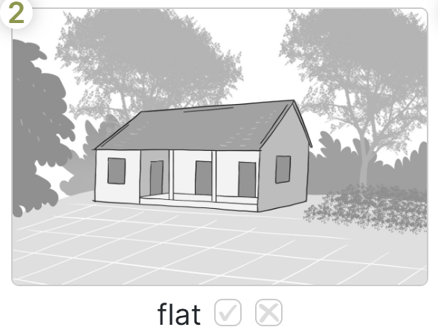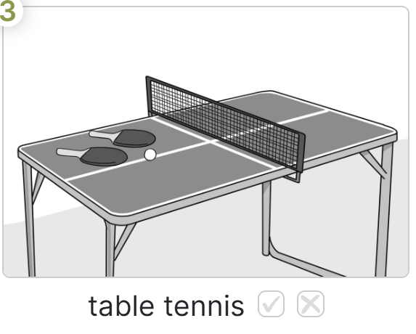
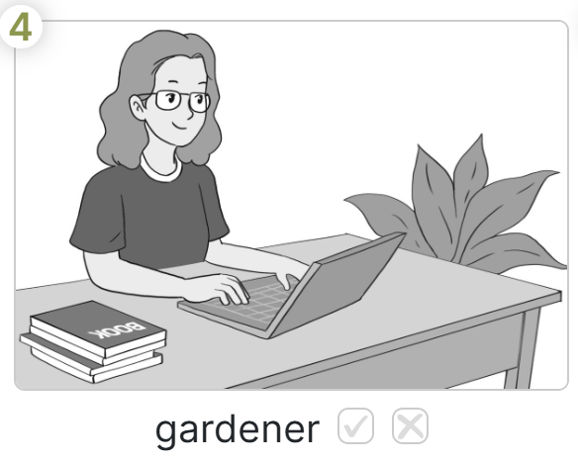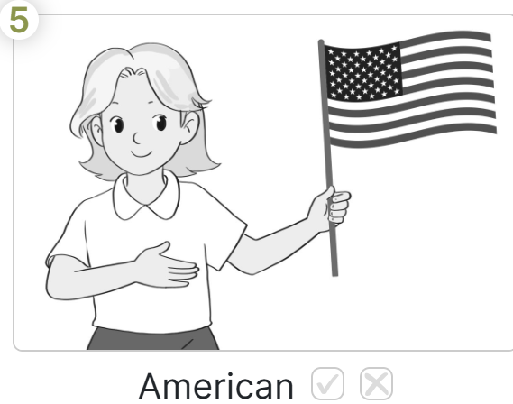

TASK 2. Read and complete. (1.25 marks)

active cooking helpful is table tennis
This is my friend. Her name is Sue. She (1)………………American. Sue is(2)……………… She likes playing(3)…………………….. in her free time. She usually goes swimming at the weekend. Sue is(4) ……………………………., too. She helps her mother with the (5) ……………………………… in the evening. I am happy that I have a nice friend like Sue.

WRITING (2.5 MARKS)


TASK 1. Look and write. (1 mark)




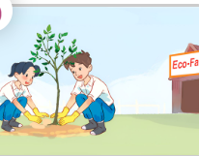
latnp eerts
rpjoctes od

solfrew

anialmyas

4
3
2
1

TASK 2. Make sentences (1.5 marks)
1. live/ Do you/ that building/ in/?
4. a reporter/ I’d like/ in the future/ to be

2. your brother/ What’s/ like/? 5. about yourself/ tell me/ you/ Can/?

3. interesting/ Because/ it’s 6. the fish/ yesterday/ he watched

